

Accessing Palo Alto pa 220

Marvin Boonnantakul

Purpose: To have a factory reset palo alto pa 220 firewall that wipes its configuration, returning it to its default and a brand new state which later can be accessed through the GUI web to be configured for future lab usages. Inside the web you will have the priority to set rules, monitor traffic and update the system.
Background Information on lab concepts: The purpose of a Firewall is to help secure and protect your network by controlling the traffic of your network. Even though a firewall itself is a security system it can be seen as a barrier between your network and the outside world network as well. Specifically, the Palo Alto PA 220 is made smaller to a medium size business, which inspects the network at an application level to protect the network from advanced threats.
The target of this lab is to factory reset the palo alto pa 220 given to me into its default state. This allows me to further complete and do more research on this firewall. By connecting the computer into the firewall using the console cable and the maintenance recovery tool, the firewall was able to reset to the default configuration with “admin” being the log in and password for the new admin to configure into, to monitor and manage the device needed.
Lastly the new admin must direct themselves to the web to furthermore configure the device and the network. Without a factory reset firewall I will not have access to the firewall due to an unknown password, having a harder time reaching the GUI web due to the IP address that has not been changed, or the old rules from the previous admin that might block traffic, preventing management access inside the GUI web. This gives the firewall a fresh new start.

Lab Summary: This lab taught me how to access and manage a Palo Alto PA-220 firewall from scratch. I started by connecting my computer into the firewall through a console cable to use the maintenance recovery tool, which let me put the device back to its factory settings. After a reboot, I signed in with the default admin account, changed the password to something secure, and made sure I could manage it. Lastly, I opened the firewall's web interface through its management port, which showed I could talk to the device just fine, giving me access to the GUI web. This lab showed me how to bring a firewall back to square one and get it ready for more setup.

Screenshots:
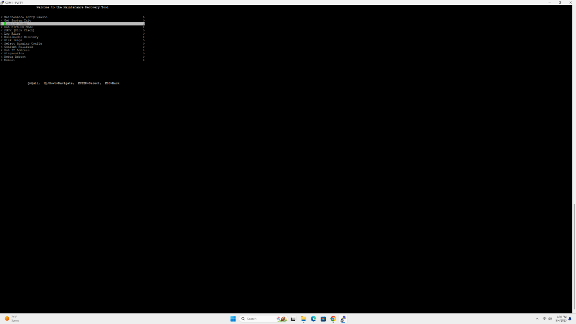
After booting into the firewall you will be put into the maintenance page. Once you are in this maintenance page you will need to select “factory reset”
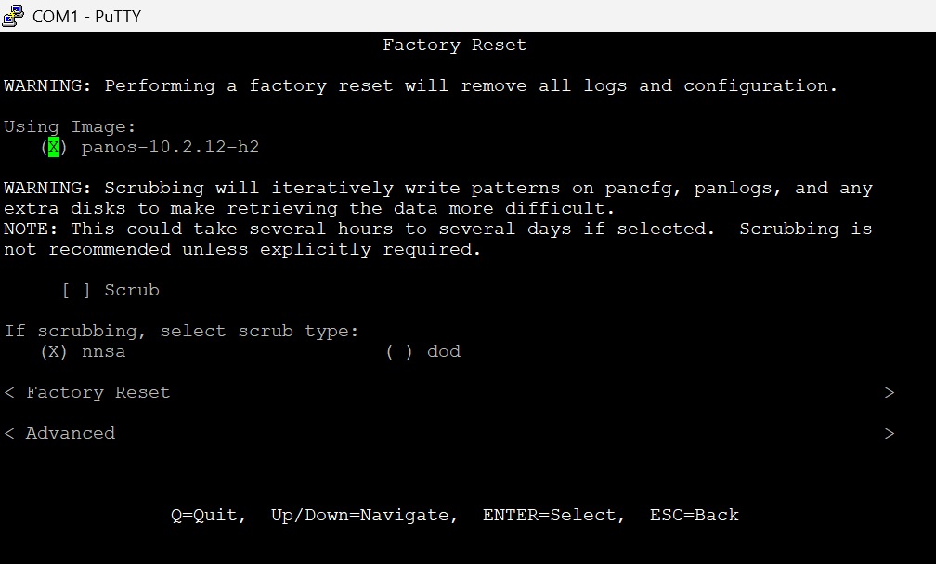
Once you are in this page you will want to select “Factory Reset” to factory reset
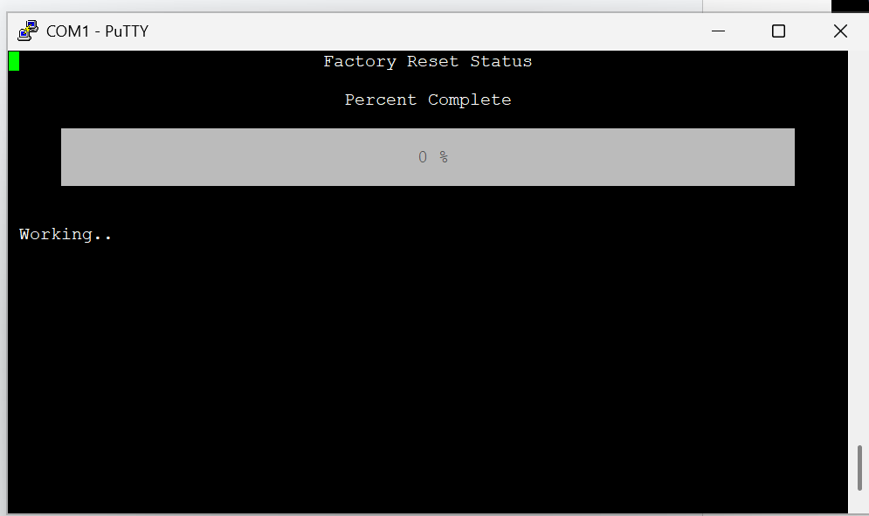
This will be the page after you select “Factory reset”. This page shows the status of the factory reset completion in percentage.
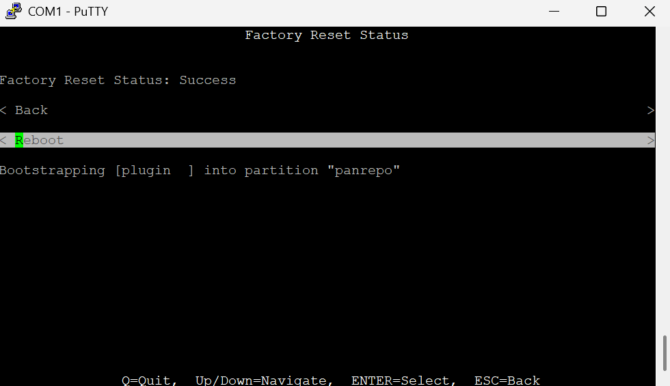
Once you are sent to this page you will need to select “reboot” to completely finish with factory resetting by rebooting the firewall.
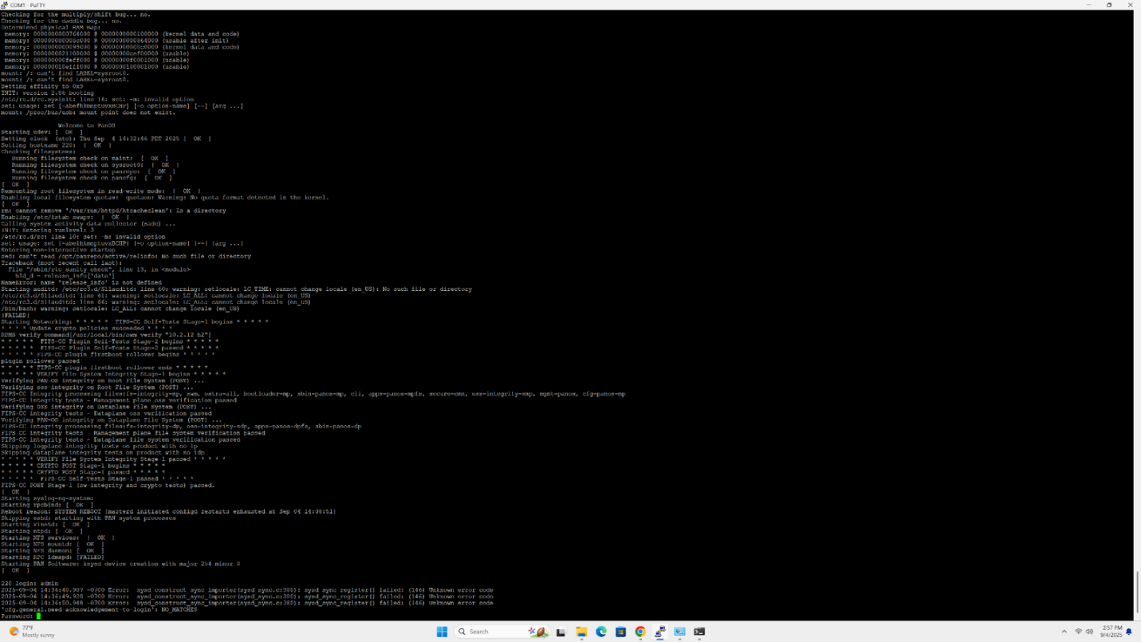
Once you reboot the firewall you will be prompt into the page. As a result, you will be required to put in the default login and password (admin/ admin). Once you have privilege you will have the ability to change the password into your own administrative password of your choice.
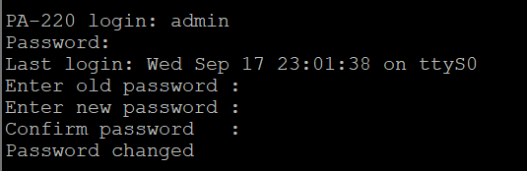
Once you have access to the firewall you will have access to the GUI web in a browser.
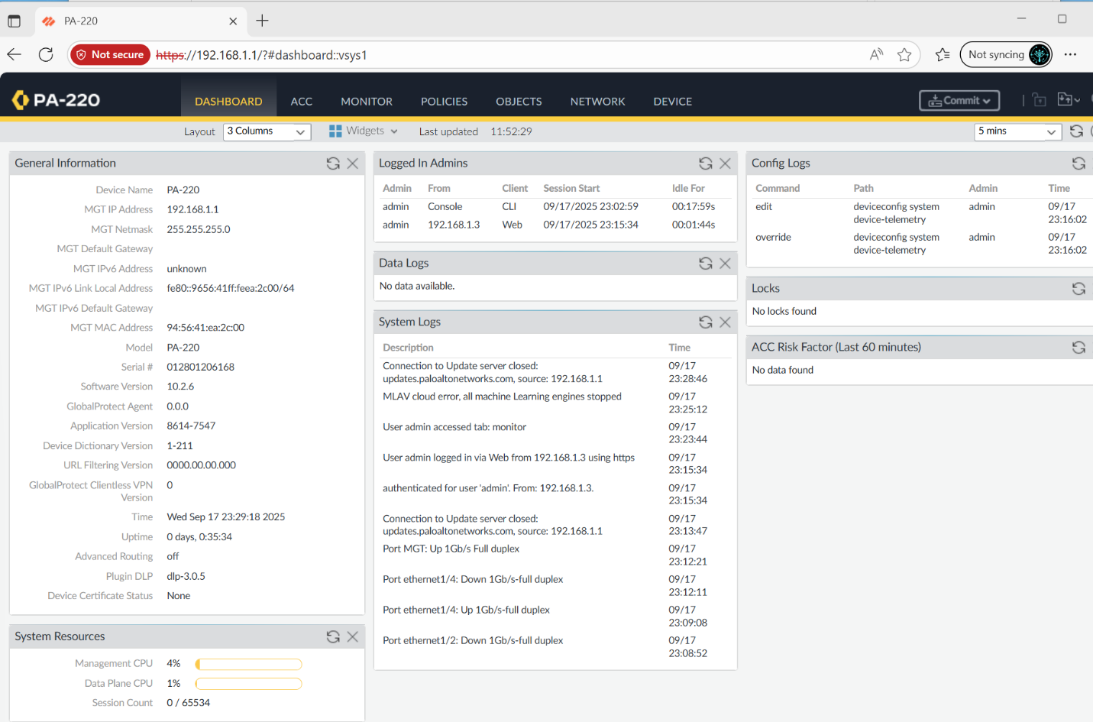
In the GUI web you will have access to configure the firewall in depth.

Lab Commands: N/A
Network Diagram with IP’s:
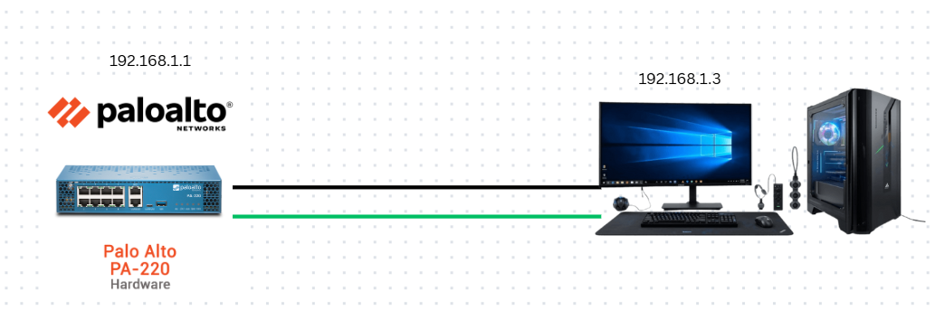
Configurations Show run on all routers involved: N/A
Show IP route on all routers: N/A
Problems: During the process of factory resetting, some firewalls had issues which were not fixable without the Palo Alto networks administers help. This leads us to change firewalls and check on each firewall until we find a firewall that works properly.
Conclusion: In this lab, I factory reset a Palo Alto PA-220 firewall to its factory default state to be able to change the password and configure the firewall appropriately by using the console and the maintenance recovery tool. Once I was logged into the admin account with the default login and password of admin, I had the ability to set a new password. I configured and verified the management interface IP to be able to connect to the firewall’s web GUI. This lab illustrates how to reset and secure a firewall for future configurations.
